# CS 255 System Design Document Template

## UML Diagrams

### UML Use Case Diagram

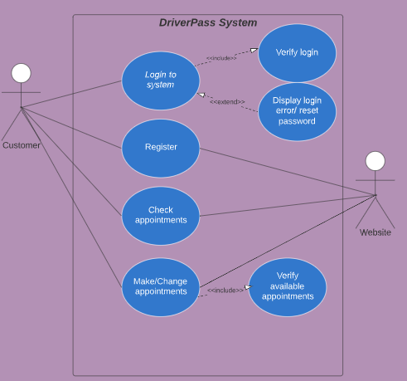

### UML Activity Diagrams

Customer activity diagram

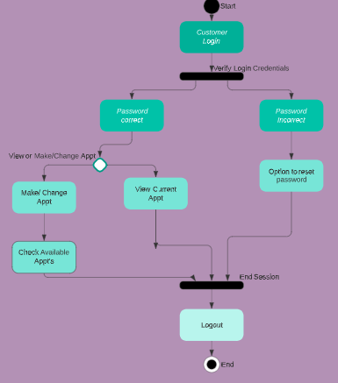

IT Admin activity diagram

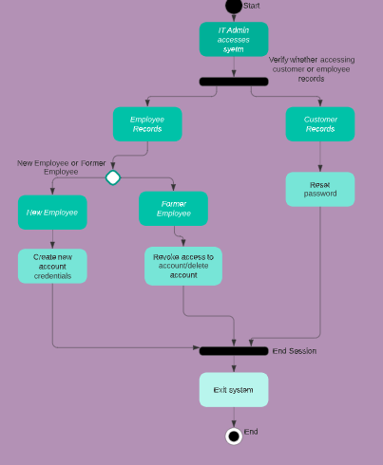

### UML Sequence Diagram

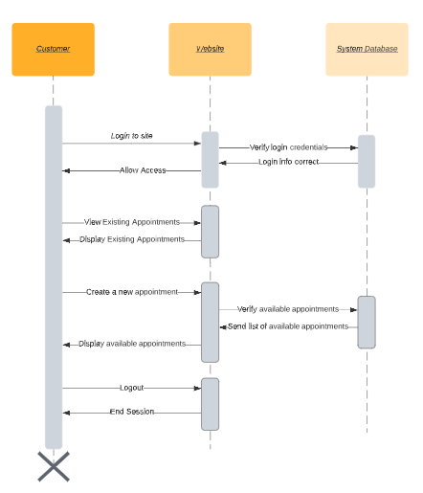

### UML Class Diagram

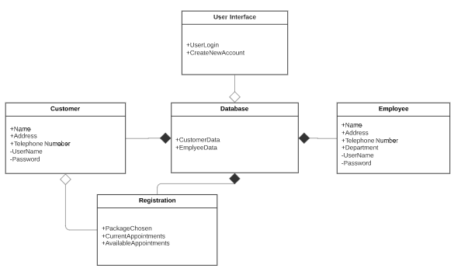

## Technical Requirements

*The system will require hardware, such as a computer or mobile device with internet access. The system will require a browser installed to access the website interface. The system will require a secure database to hold customer and employee account and login information. The database will also compile updated information on current registrations and appointments so users can’t overbook appointments. It will remove appointments from the list of available appointments that are shown to the customer, when a slot is filled by another customer. The system will require an interactive website interface that the customers can use to manage their accounts, appointments and registrations.*